**ACTIVATING** **DOWNTIME**

1. Open **Settings**
2. Tap **Screen Time**
3. Tap **Downtime**

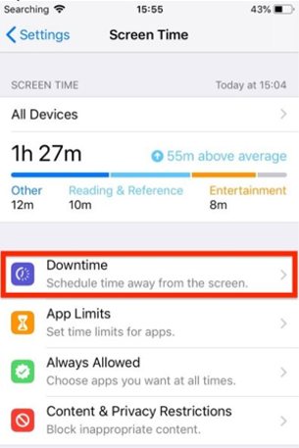

1. Slide the **Downtime** **toggle** to enable it and select a **Start** and **End** **time** using the dropdown hour and minute wheels

