**INCLUDING** and **EXCLUDING APPs** fromDowntime

To continue using certain APPs during Downtime, add these to your Allowed Apps list.

1. Open **Settings** andtap **Screen Time**
2. Tap **Always Allowed**

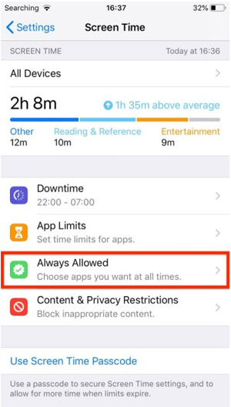

1. Simply tap the green plus button beside the APP you wish to add to the list
2. Alternatively, tap on the red minus buttons to remove APPs from the list

