**SETTING APP CATEGORY** Limits

1. Open **Settings**
2. Tap **Screen Time**
3. Tap **APP Limits**

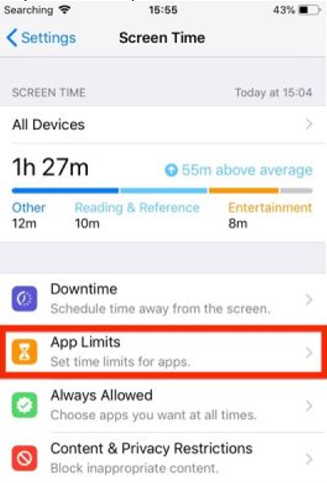

1. Tap **Add Limit**
2. Select the categories in the list that you'd like to include in the time limit and tap **Add**   
   Alternatively, select **All Apps & Categories** and tap **Add**

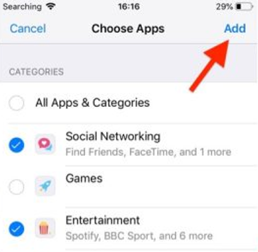

1. **Select** a **time** **limit** using the hour and minute wheels  
   If you wish to set different limits for each day of the week tap **Customize** **Days and t**ap **Back** when you're done

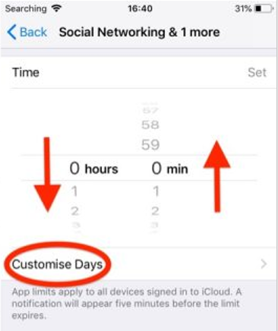

**Please note:**

Ignoring the time limit is an option. Simply by tapping on *Ignore Limit*, boys will be able to continue using the APP. Boys may also select *Reminded Me in 15 Minutes* or *Ignore Limit for Today*.

